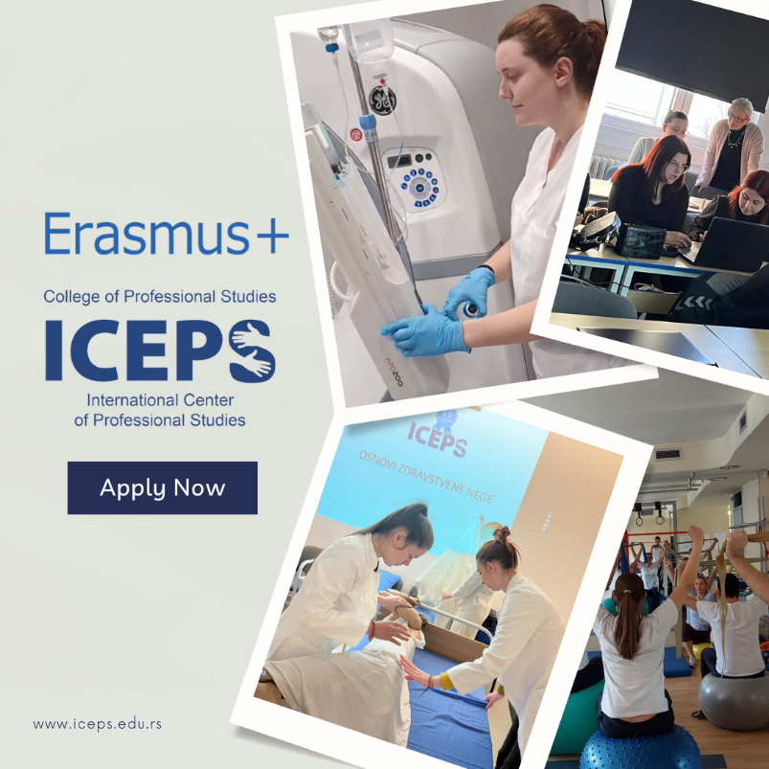
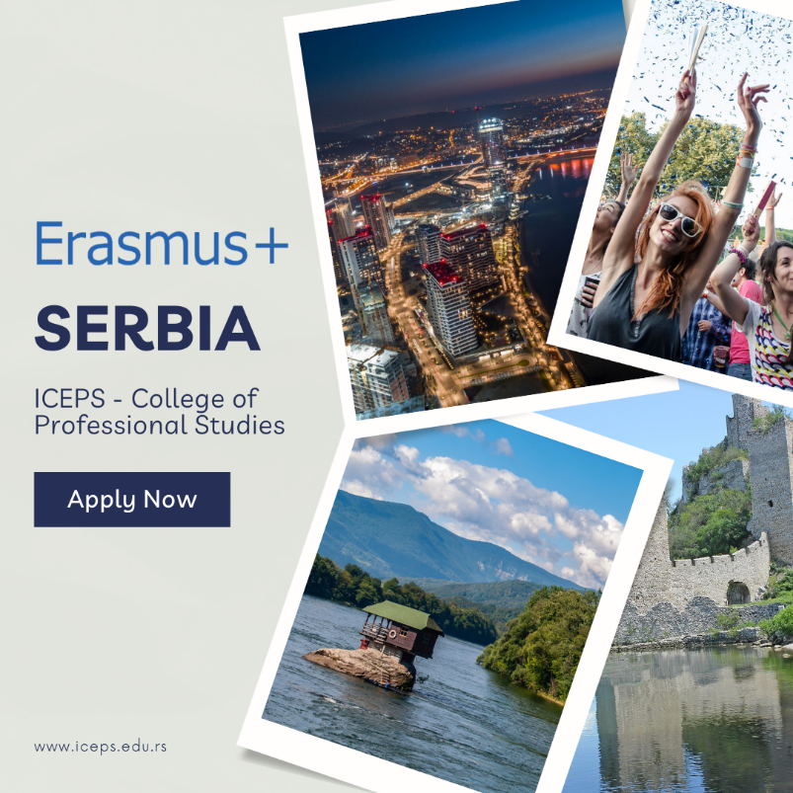
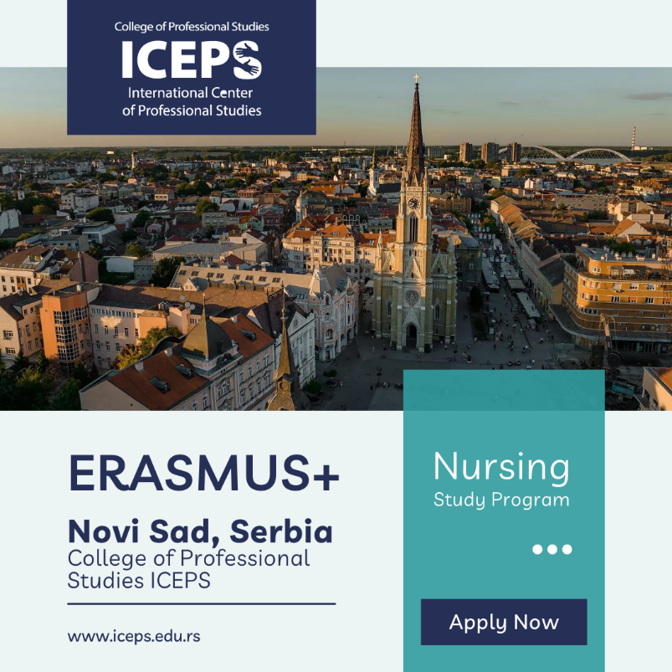
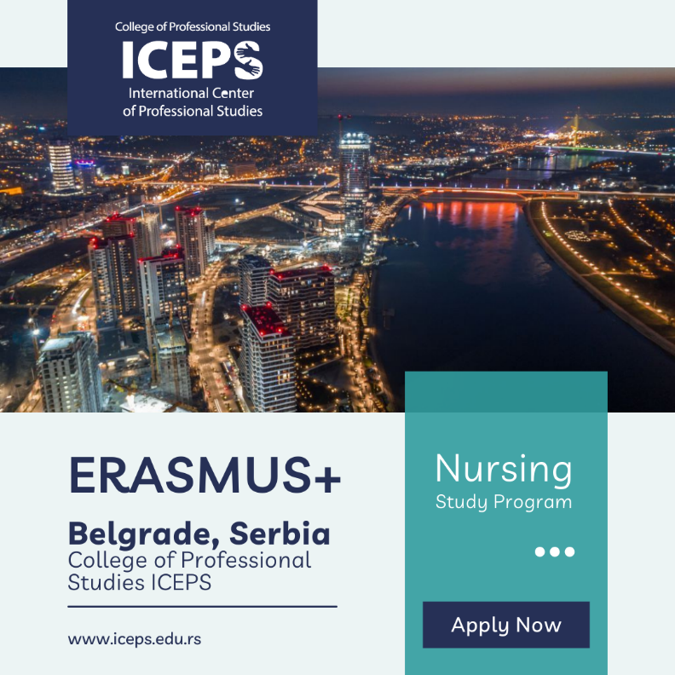

Please note that you have a visual and text for both Belgrade and Novi Sad depending on which city you decided to promote for your students’ mobility (we talked about this during our Zoom call). The first text and visual is for Belgrade, while the second one is for Novi Sad.
***
Text for the visuals:
Apply for the Erasmus+ student mobility at the College of Professional Studies ICEPS in Belgrade, Serbia!
Outspoken, adventurous, proud and audacious. Belgrade ('White City') is by no means a 'pretty' capital, but its gritty exuberance makes it one of Europe's most happening cities. With a population of over 1.6m people from all over the world, Belgrade is a melting pot for all the cultures which it houses, and with the #1 nightlife in the world, according to Lonely Planet, Belgrade is a true gem in the heart of the Balkans with something to offer for everyone.
Contact us for more information if you want to get the chance to live and study in Belgrade during your Erasmus+ mobility!
Apply for the Erasmus+ student mobility at the College of Professional Studies ICEPS in Novi Sad, Serbia!
Open, tolerant, friendly and proud. All these epithets come to life when we think of Novi Sad. Stuck between the picturesque plains of Vojvodina and the hills of Fruška Gora, with the mighty Danube flowing in between, Novi Sad is renowned as the liberal city of music, art and fun. Standing proud as Serbia’s cultural heart, it is a place where 26 different cultures of the 26 recognized ethnic groups located in Vojvodina are blended as one. With a population of 350.000 people, of which more than 50.000 are students, the city’s efforts towards making Novi Sad a vibrant, youthful city, oriented towards the youth and culture were rewarded with the tittles of European Youth Capital and European Capital of Culture in 2019 and 2022.
Contact us for more information if you want to get the chance to live and study in Novi Sad during your Erasmus+ mobility!
Heard about the lakes of Slovenia, the beaches of Croatia, the valleys of Bosnia? But what of Serbia and its canyons, mountains and weird alien-constructed rock formations? What of Europe’s biggest desert and extraterrestrial stones that can heal you? From the vast plains in the north to the high mountains in the south, Serbia will constantly surprise you with the diversity of its landscapes and the life that inhabits it. Many plant and animal species which are virtually extinct elsewhere in Europe have found sanctuary here.
Discover that magic during your Erasmus+ mobility at the College of Professional Studies ICEPS! Applications are open! Do not miss the chance!

Meet your Erasmus+ host in Serbia!
College of Professional Studies ICEPS is recognized across the country and beyond as a school of excellence and quality in medical studies. By taking part in the Erasmus+ program and welcoming incoming students from Austria in Radiology course, it proved its key competences and strengths – best lecturers and mentors with vast experience and still active in their professions and reputable health institutions with moder equipment and adequate conditions for learning. Proud of our success and with an open attitude towards new incoming students, we look forward to welcoming you and taking part in enriching your personal and professional development! Welcome to ICEPS!

